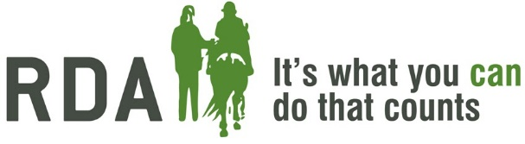
Horse and Pony Sponsorship
Which horse and pony would you like to sponsor?
Please tick the appropriate option or mark with a “Y”
Individual Sponsorship (£4 per month)
Silver Corporate Sponsorship (£250 per year)
Gold Corporate Sponsorship (£500 per year)
Individual Sponsor – Please Complete:
Contact Name
Address Line 1
Address Line 2
Address Line 3
Post Code
Mobile Number
Email Address
I confirm that I am a UK Income or Capital Gains taxpayer. I have read this statement and want Herefordshire Riding for the Disabled Association to reclaim tax on the donation detailed below, given on the date shown. I understand that if I pay less Income Tax /or Capital Gains tax in the current tax year than the amount of Gift Aid claimed on all my donations it is my responsibility to pay any difference. I understand the charity will reclaim 25p of tax on every £1 that I give.

I want to Gift Aid my donation for horse sponsorship and any donations I make in the future to Herefordshire Riding for the Disabled Association
Type name below or sign to confirm agreement with gift aid declaration
Name |  | Date
Please complete the direct debit mandate on the reverse or go to our website to set up a new direct debit.
Corporate Sponsor – Please Complete:
Contact Name
Company Name
Address Line 1
Address Line 2
Address Line 3
Post Code
Mobile Number
Email Address
Please either forward a cheque payable to ‘Herefordshire RDA’ or use the bank details below to BACS the payment:
Bank Account No. (CAF) | 40-52-40 | Sort Code | 00030478

ALL SPONSORSHIP REQUESTS WILL BE CONFIRMED BY EMAIL AND APPROPRIATE PHOTOS/CERTFICATES SENT BY POST
admin@rdahereford.org 01432 870831

